Youth Climate Leadership Program

Communications Toolkit
Help us recruit our first leadership cohort!
Thank you to all of our amazing community partners who have contributed your expertise and time to help us develop the City’s Youth Climate Leadership Program. We welcome your support in getting the word out this summer to youth and families about this opportunity to participate in the pilot cohort of Vancouver youth climate leaders.
This toolkit includes sample copy and graphics to use in your social media, e-newsletters, and other regular outreach. Please feel free to make it your own! We hope this makes it easy to plug into your communications calendars.
Applications are due Sunday, August 4, 2024, by 9 p.m. PDT. More program details can be found at cityofvancouver.us/yclp.
E-newsletter Blurbs

Short (45 words): Youth Leaders – Apply Today!
Join the Vancouver Youth Climate Leadership Program! In this program, students will collaborate with peers across the city, develop sustainable solutions, and gain valuable skills to advocate for a better future. Applications are due August 4. Learn more and sign up for updates at cityofvancouver.us/yclp.

Long (131 words): New Youth Climate Leadership Program – Applications Now Open
This Fall, 12 high school students will come together for the City’s new Youth Climate Leadership Program. In this program, students will collaborate with peers from across the city, develop sustainable solutions, and gain valuable skills to advocate for a better future. It’s not just about learning—it’s also about doing. The cohort will dive into exciting projects, attend educational field trips, and develop skills to tackle real-world community challenges.

Students don’t have to be climate experts to successfully apply. The City is looking for youth that are interested and curious about how climate change impacts our communities and the diverse roles we can each play in having a positive impact on our City. Applications are due Sunday, August 4, at 9pm PDT. Learn more and sign up for updates at cityofvancouver.us/yclp.

Social Media

Sample copy
Build your climate resume with the @VancouverUS Youth Climate Leadership Program this Fall. Applications are due Aug. 4. Learn more: cityofvancouver.us/yclp

Calling Vancouver area high school students! Join the City of Vancouver Youth Climate Leadership Program to take action for our community and build your skills to advocate for a better future. Applications are due Aug. 4. Learn more: cityofvancouver.us/yclp

School’s almost out, but don’t put away your keyboards just yet. @VancouverUS is looking for 12 high school students to join a new Youth Climate Leadership Program this Fall and collaborate on a community climate project. Learn more: cityofvancouver.us/yclp

Want to learn more about climate action in your community? @VancouverUS is looking for 12 high school students to join a new Youth Climate Leadership Program this Fall and collaborate on a community climate project. Learn more: cityofvancouver.us/yclp

Graphics
Graphics sized for use on Facebook, Instagram, and Instagram Stories are available for download at www.cityofvancouver.us/yclp.
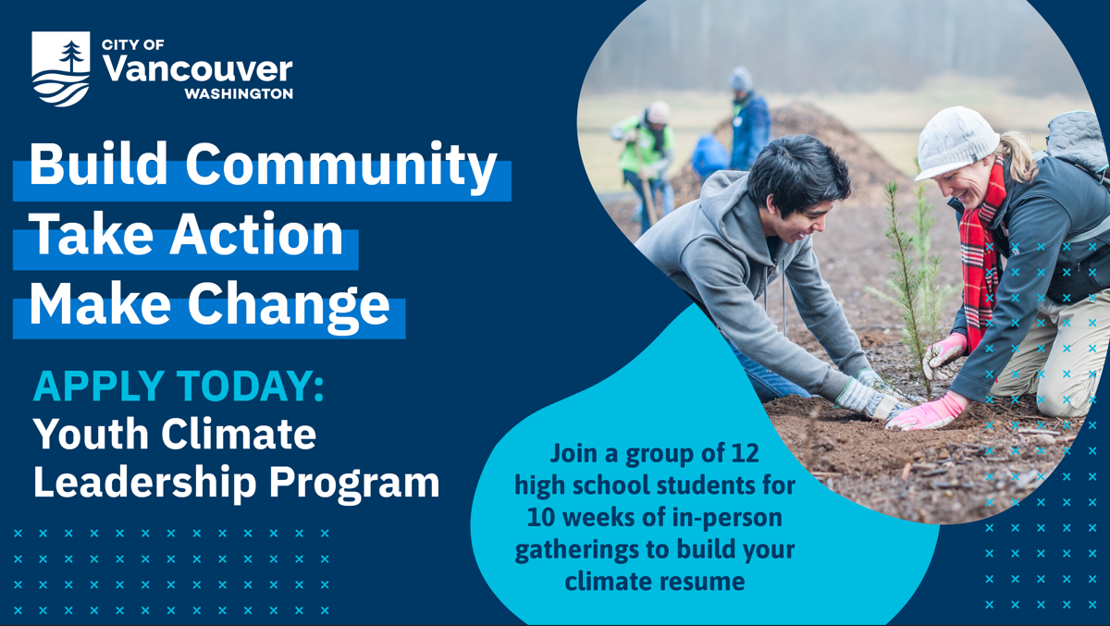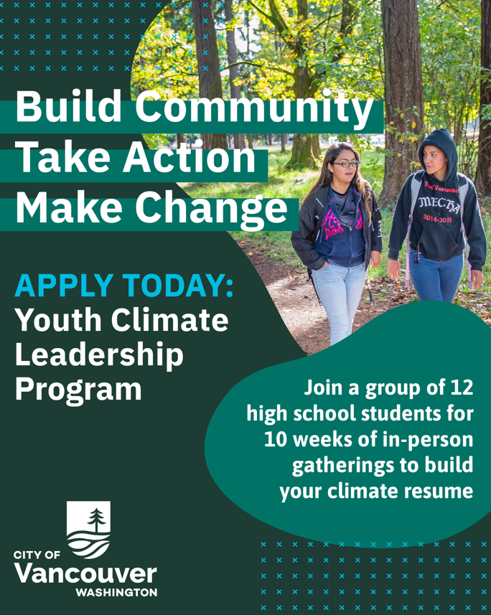

Printable Flyers
Flyers are available in multiple languages for download and distribution at www.cityofvancouver.us/yclp. Contact stacey.dalgaard@cityofvancouver.us if you have an event and would like to receive printed copies to distribute to Vancouver youth.

